Graham Cracker Square

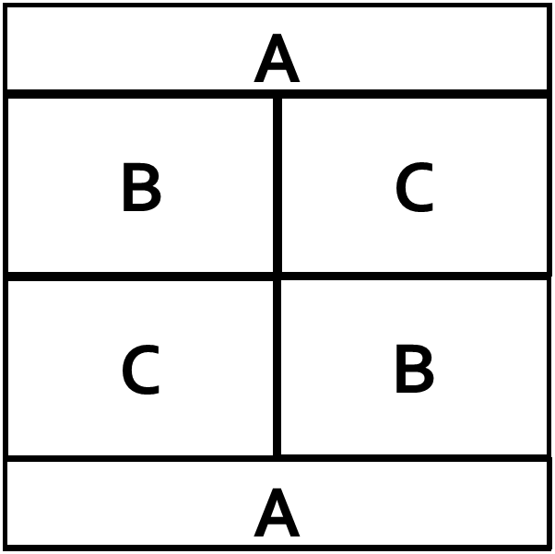

Sashing Strip A—Cut 2 per block 2” x 9 1/2” (This will be done at workshop)
Use Contrasting Fabrics to Cut: (Use contrasting shades of green, blue, brown gray, gold (but not yellow), red or cranberry. No florals or polka dots)
Rectangle B—Cut 2 per block 3 1/2” x 5”
Rectangle C—Cut 2 per block 3 1/2” x 5”
Sew rectangles together and add sashing strips to top and bottom. Press and square to 9 1/2”

